**\*Definition:**

-RMS

-Restaurant Management System.

-A Software that provide facility to make easier operation for user and admin both.

**\*Technologies used:**

-core java

-advance java

: servlet

: jsp

: MVC

-html

-CSS

**\*Purpose:**

-when you go to the restaurant many times you can’t get table easier you must have to wait for table.

- After go to the Restaurant some time your favourite dish is over.

-So, our software provides you to facility to book your table at sitting home by paying booking fees and you also see menu which item is available now or not.

**\*Facility Provide:**

-Security

-Usability

-Easy to Use

-Reliability

**\*Diagrams:**

**1)Use Case:**

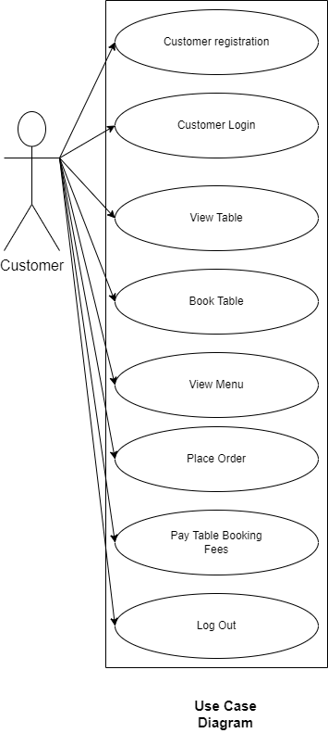

**2)DFD:**

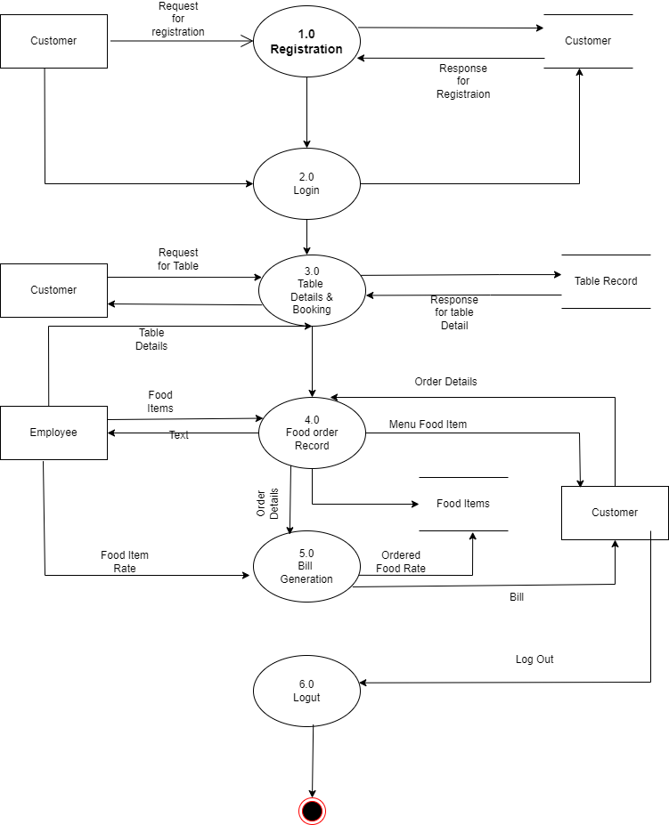

**3)Class:**

